Laboratory 1: Introduction to Principles of Chemistry
Minneapolis Community and Technical College
Dept. of Chemistry v.1.22

Instructions: You will need access to the Microsoft office suite; MS Word and Excel. To install this software on your personal computer, go to this WEBSITE (Ctrl-click on links). Use your username (StarID@minnstate.edu) and password for access.
INSTALL the software to your computer. The browser-based Office 365 won’t work for this class.
When solving chemistry problems, you must always show your work. Answers that require mathematical calculations can be hand-written. All other question responses must be typed. No Exceptions.
Answer the following questions. When finished, convert this MS Word document into a pdf file. Then, email the file to your instructor before the due date.
For security reasons, only pdf files are accepted. Other file formats will be immediately deleted.
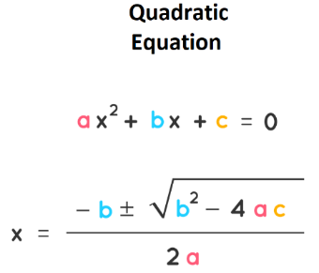
- Solve 3x² + 7x - 14 = 0 for both values of x using the quadratic equation shown at right.
Insert your handwritten solution (all steps) in the space below:

- Describe your strategy for succeeding in this chemistry course. (Minimum 5 well-written sentences)

- Principles of Chemistry has many prerequisites. Below, list the math and chemistry courses you’ve taken in the last 5 years. Include when and where you took them.
Note: your response will not result in you being automatically dropped from this course. However, if it looks like you lack certain prerequisites, I will be in touch with you.

- You must have your hardcopy lab notebook with you when you attend lab. In the space below, replace the figure with side by side pictures of the i. front cover ii. table of contents iii. Number all pages and include page 53 below.
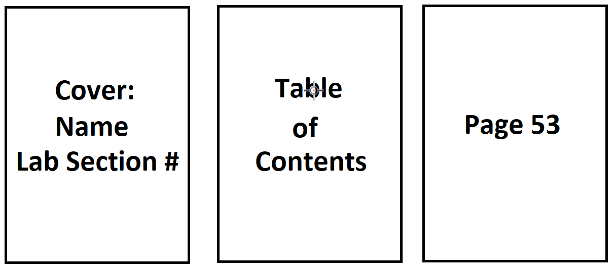

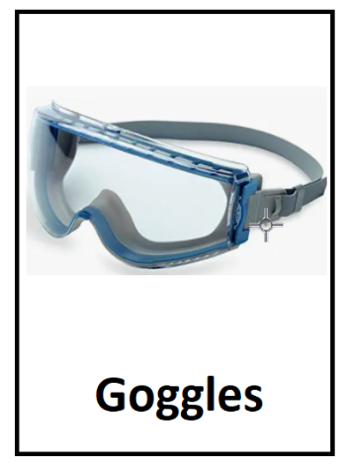
- Goggles and masks are required when we meet in lab. Use a permanent marker (Sharpie) to write your name on your goggles. Replace the picture below with a picture of your goggles (name showing).
Note that goggles must be of the splash-proof variety shown below ( ~$17 on Amazon )

