Spectroscopy Lab Worksheet Name ______________________
Date of Experiment ___________
Lab Section __________

Part I: Hydrogen Line Energy Calculations

Step 1: Convert each of the hydrogen line wavelengths from nm into meters:
Show one dimensional analysis calculation below:

Step 2: Calculate the frequency () for each line using the relationship = c where c = 3.00 x 10⁸ m/s
Show all four calculations below and report your frequency results with correct units.

Step 3: Calculate the four light energies using the relationship Energy = h where h is Plank’s constant and is
equal to 6.62607 x 10⁻³⁴ Js. Show all four calculations below and report your answers with correct units.

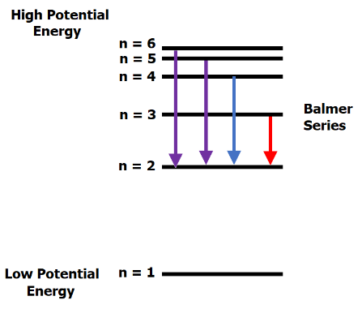
Part II: Experimental vs theoretical energy comparisons.

The Bohr model of the atom describes electrons in orbits around the nucleus. These orbits have potential energies that increase as the distance between the negative electron and the positive nucleus increases. The ladder diagram at right illustrates these energies as discrete energy levels from n = 1 up to n = 6. Note that there are an infinite number of energy levels available to the electrons in an atom and that their spacings become closer as n increases.

The diagram also illustrates the “Balmer Series”; electron jumps or transitions from high energy levels to low energy levels. These electron transitions correspond to the visible hydrogen line spectrum. As an electrons descends to lower energy levels. The energy lost by the electron is given off as the light we see in the line spectrum.

Step 1: Determine the energies corresponding to the n = 1 .... n = 6 energy levels.

$$E= -2.18 x {10}^{-18} \left(\frac{1}{n^{2}}\right)$$

Use the equation above to determine the energies of each of the six energy levels n = 1 through n = 6.
Show all six calculations below:

Step 2: Calculation of energy lost by electrons moving down the ladder diagram

When an electron moves between levels its energy changes. This energy change is determined via the
following equation:
E_{electron} = E_{final} - E_{initial}

Use your energy values from Step 1 to determine the energy changes for the Balmer Series:
n = 3 → n = 2 n = 4 → n = 2 n = 5 → n = 2 n = 6 → n = 2

Show your four calculations below (watch your mathematical signs!) :

Step 3: Determination of light energy.

The energy lost by the electron is energy GAINED by the light. Consequently, we change
the sign on each of the four results in Step 2 before reporting them as light energies.

Do this and record your results in the table below in the “Theoretical Light Energy” Column.

Line Color | Theoretical Light  Energy | Experimentally  Determined Light Energy
Red
Blue
Purple
*Violet

*You may not have observed this line as it is very faint.

Step 4: Refer to Part I, Step 3 and record the energies calculated there in the column “Experimentally
Determined Light Energy” Column.

Questions:

1. How do the theoretical and experimental energies above compare?

2. Why is there darkness between lines in a line spectrum?

3. The “Lyman Series” is a line spectrum that is generated by electrons that descend from high energy
levels to the n = 1 energy level. Why is it we can’t see these lines?

Part III: Flame Emission Spectra

Step 1: Record the color of each flame in the table below

Flame Color
NaCl
CaCl₂
NiCl₂
SrCl₂
LiCl
CuCl₂
Unknown

Question:

1. What metals were present in the unknown?

Part IV: Molecular Absorption

Step 1: Place an “X” in each square corresponding to each color of light that was transmitted for each dye.

Dye Color | Red  Light | Orange Light | Yellow Light | Green Light | Blue  Light | Indigo Light | Violet Light
Red
Blue
Green
Yellow
Red/Green
Blue/Yellow
Red/Blue

Question:

1. If you were to repeat the experiment and positioned red, blue, green, and yellow dyes in line, what color(s) of light would be transmitted?

Part V:

Insert images of all clearly LABELED spectra (10 total) below.

