C1151 Empirical Formula Report Name_________________________
Date of Exp. ________________
Lab Section ________________

 |  | Mass (g)
Before Heating | 125 mL Flask
 | 250 mL Beaker
 | 125 mL Flask & Zn
 | 125 mL Flask & Zn & I₂
 | Initial Zn mass
 | Initial I₂ mass
After Heating | 125 mL Flask & Zn
 | 150 mL Beaker + product
 | Product mass
 | Excess Zn mass
 | Mass of I₂ Consumed
 | Mass of Zn Consumed
Calculated Product  Values | moles _{Zn}
 | moles _{I}

Empirical Formula
(4 significant figures*)

Empirical Formula
(single digit subscripts )
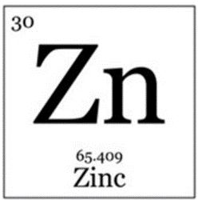
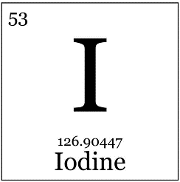

Answer (Type) answers to the following questions:

- Why is the exact amount of methanol used in this experiment not important?

- What is responsible for the color of the solution before you begin heating?

- What is the purpose of rinsing the Zn_{(s)} with methanol several times once the reaction is complete?

- I₂ is the limiting reactant in this experiment. Give two experimental observations that support this fact.
(An observation in this case is something you SEE.)
- List three possible molecular formulae for the empirical formula C₃O₅H₁₀.
If the molar mass of the compound is approximately 126 g/mol, what is the molecular formula?

- A compound is known to be 72.6% carbon, 8.1% hydrogen and the remainder oxygen. What is the compound’s empirical formula?
For this problem, you can handwrite your solution, photograph it and Insert it into this document.
This is a very useful technique that will come in handy in the future.

