Titration of Acetic Acid in Vinegar Name_____________________
Minneapolis Community and Technical College Section_______

NaOH Standardization

 |  | KHP  Trial 1 | KHP  Trial 2 | KHP  Trial 3
Mass: Beaker | grams
Mass: Beaker + KHP | grams
Mass: KHP | grams
Molar Mass: KHP | g/mol
Moles: KHP | mol
Initial Burette: NaOH | mL
Final Burette: NaOH | mL
Volume: NaOH | mL
Moles: NaOH | mol
Concentration: NaOH | M | _{8 decimal digits} | _{8 decimal digits} | _{8 decimal digits}
Average Concentration: NaOH | (mol/L) | - _{decimal digits}

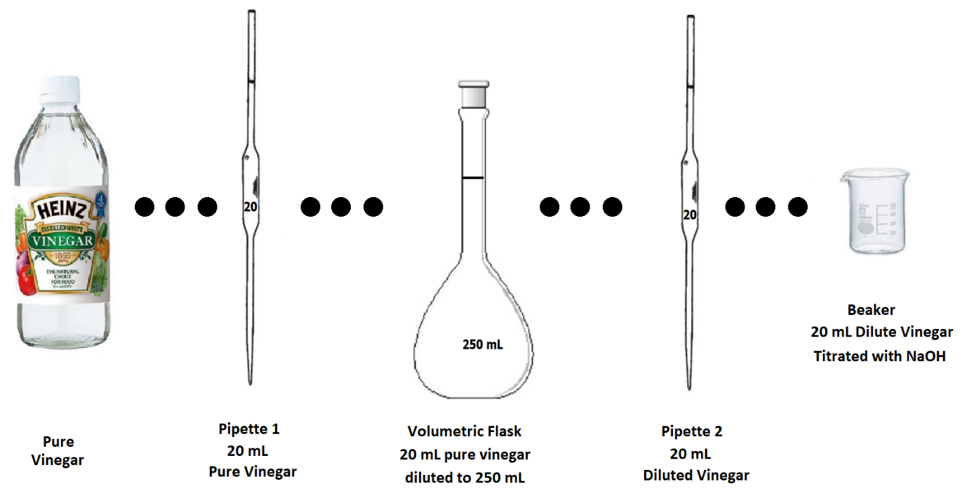
Vinegar Titration Calculations: (Refer to picture above)
 |  |  | Vinegar Trial 1  (Rough) | Vinegar Trial 2  (Careful) | Vinegar Trial 3  (Careful)
Average Concentration: NaOH |  | (mol/L)
Initial Burette: NaOH |  | mL
Final Burette: NaOH |  | mL
Volume: NaOH |  | mL
Moles: NaOH |  | mol
Moles: CH₃COOH Beaker |  | mol
Pipette 2: Moles CH₃COOH |  | mol
Pipette 2: Volume |  | mL
Pipette 2: CH₃COOH Conc. |  | M
Volumetric Flask:  Moles CH₃COOH |  | mol
Volumetric Flask:  Volume |  | mL
Volumetric Flask:  CH₃COOH Conc. |  | M
Pipette 1: Moles CH₃COOH |  | mol
Pipette 1: Volume |  | mL
Pipette 1: CH₃COOH Conc. |  | M
CH₃COOH Concentration  Vinegar |  | M |  | _{8 decimal digits} | _{8 decimal digits}
Average CH₃COOH Concentration in Vinegar |  | M |  | (With CORRECT significant figures)

Questions:

- For each standardization trial determine the following: moles_{KHP}, moles_{NaOH}, volume_{NaOH} and concentration_{NaOH}. Record your results in the data table with at least 8 decimal digits. Show all calculations below
- Determine the average NaOH concentration with at least 8 decimal digits. Record this value in your data table.
Show all calculations below

- Use the average standardized NaOH concentration and vinegar titration measurements to determine the number of moles of acetic acid ( beaker) in both of the “careful” vinegar titrations. Show all calculations below.

- Determine the acetic acid concentration pipette 2. Show all calculations below.

- Determine the acetic acid concentration in the 250 mL volumetric flask. Show all calculations below. 😊
- Determine the UNDILUTED acetic acid concentration in the 20 mL pipette 1.
- Determine the acetic acid concentration in the original store-bought vinegar. Show all calculations below. 😊
- Convert the average acetic acid concentration in store-bought vinegar into mass percent. Show all calculations below.
Convert... Molarity = mol _{CH3COOH} /L_{solution} INTO Mass % = g _{CH3COOH} / g_{solution} x 100%
(Density_{vinegar} = 1.005 g/mL) .

