Spectroscopy

Minneapolis Community and Technical College

***v.3.22***

**Objective:**  To observe, measure and compare line spectra from various elements and to determine the energies of those electronic transitions within atoms that produce lines in a line spectrum.

**Prelab Questions:** Read through this lab handout and answer the following questions before coming to lab.   
 There will be a quiz at the beginning of lab over this handout and its contents.

1. How does the spacing of stationary states change as n increases?
2. For the hydrogen atom, why isn’t light produced by the n = 3 → n = 1 electron transition visible to the eye?
3. How does the energy of an n = 3 → 2 electronic transition compare to the energy of a 2 → 1 transition?
4. What is the meaning of ROY G BIV?
5. What are the meanings of the terms “absorbed” and “transmitted.”
6. How is an emission spectrum different from an absorption spectrum?
7. What is a spectroscope?
8. Where does light enter the spectroscope?

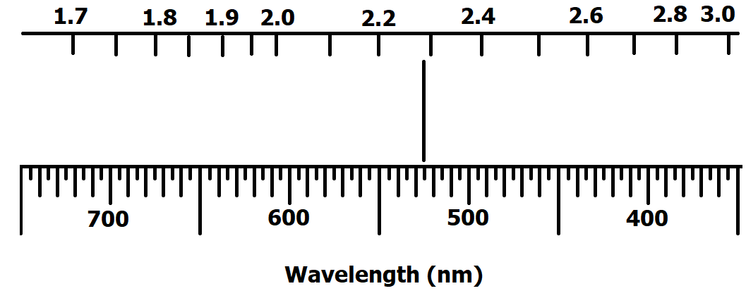

1. What is the wavelength of the spectral line displayed in the figure at right?

(Answer: 525 nm)

1. Calculate the energy corresponding to hydrogen’s n = 1 stationary state.

(Answer: -2.180 x 10-18 Joules)

##### **The Bohr Atom, Stationary States and Electron Energies**

Bohr’s theory of the atom locates electrons within an atom in discrete “stationary states” . The “n” quantum number identifies each stationary state with a positive integer between 1 and infinity (∞). Larger n values correspond to larger electron orbits about the nucleus.

Stationary states energies are described using a potential energy ladder diagram below. Electrons are forbidden from having energies between stationary states.

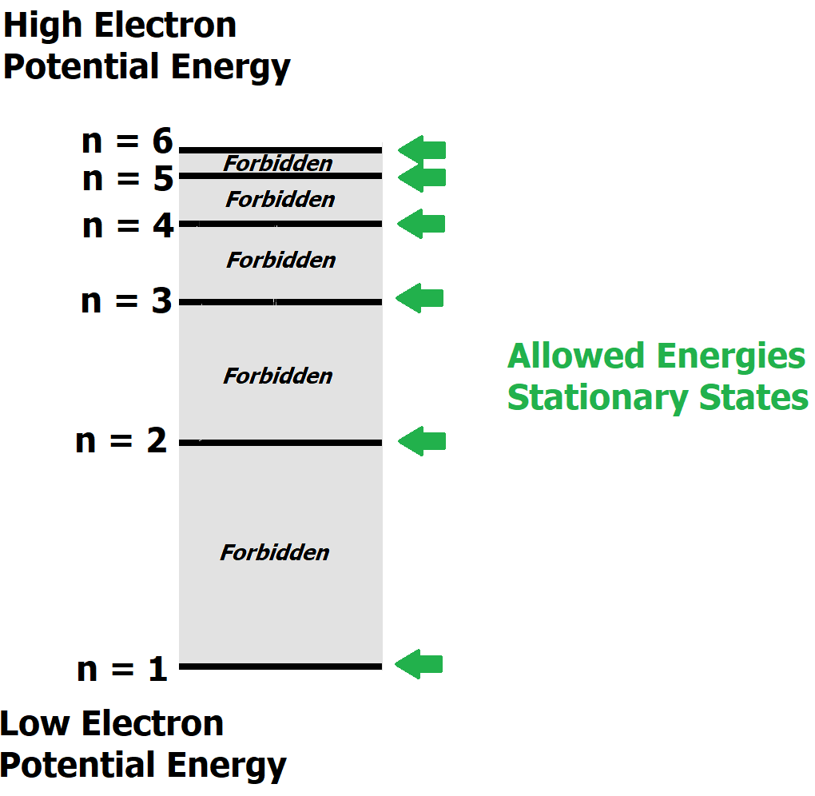

The potential energy of an electron depends on which stationary state is occupied. The lowest energy stationary state is given by n=1. Electrons found in higher stationary states have progressively higher potential energies. Thus, electrons in the n=3 stationary state have greater potential energy than those electrons in the n=2 stationary state.

The potential energy of an electron in hydrogen stationary state depends on “n” and is given by the following equation.

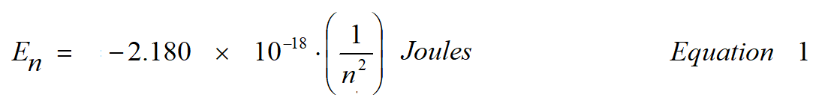

Notice that as n increases, the value of En increases as well.

An “electron transition” refers to an electron moving from one stationary state to another. As an electron transitions between stationary states, its potential energy within the atom changes. For example, when an electron transitions from n = 5 → n = 2, the electron loses potential energy that is released as light energy (Conservation of Energy).

Because electron energies are limited to only those in the ladder diagram, electron transitions can only produce light of specific energies. In the diagram below, hydrogen atom transitions all ending on the n=2 level are shown.

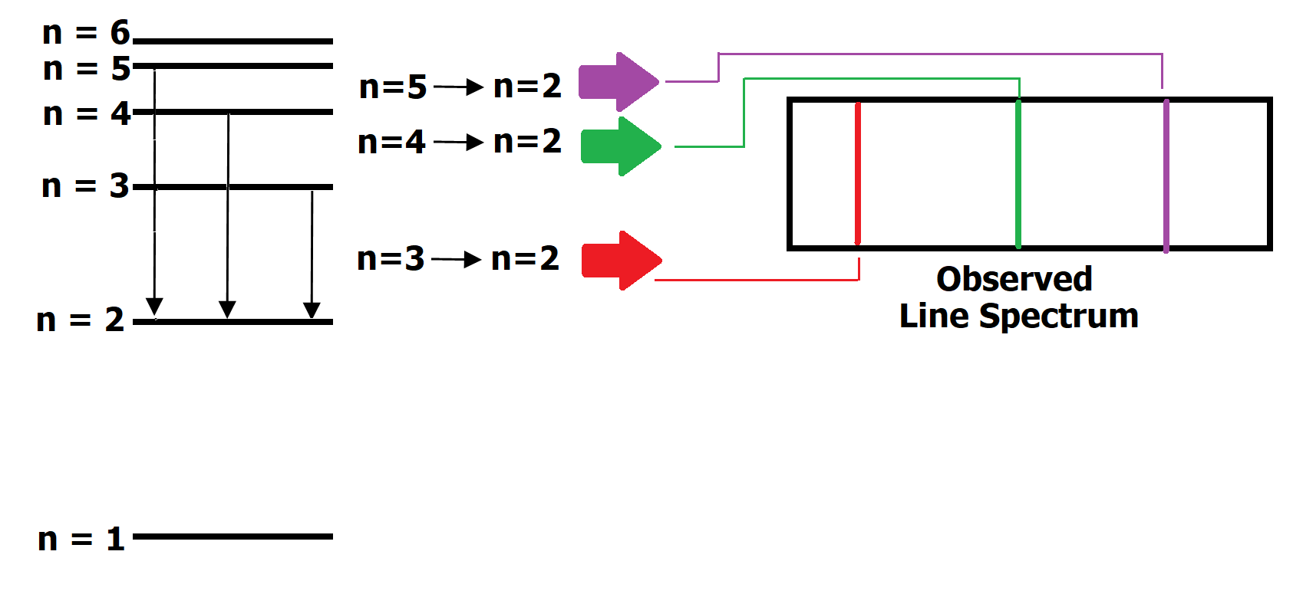

The n = 5 → n = 2 transition produces violet light that appears in the spectrum as a single violet line. Other electron transitions, n = 4 → n = 2 and n = 3 → n = 2 also produce light that is observed as green and red lines in the spectrum.

Electronic transitions between other energy levels also occur but the light released isn’t visible to the naked eye. Furthermore, upward electronic transitions are also allowed but require an outside source of energy to “promote” the electron.

**Emission Spectra: When light is produced**

When the white light produced by the sun or an incandescent light bulb is separated using a prism or spectrometer, the result is the visible spectrum where all colors are present (figure below).

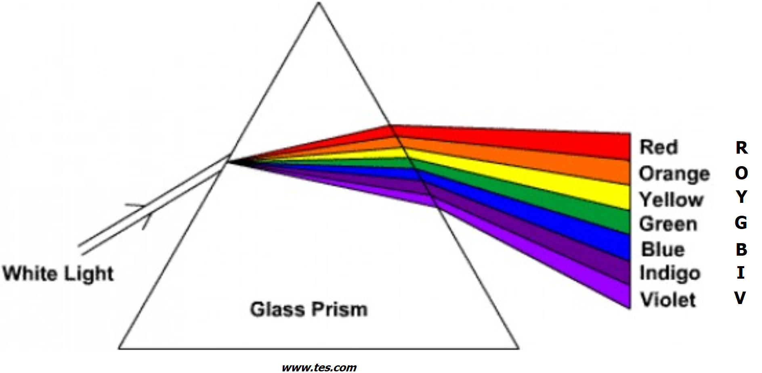

The order of the colors, given by the fictitious name Roy G. Biv lists the colors in order of increasing energy (i.e. red light is lower energy light than orange).

When the light that emerges from the prism is projected on a screen (or your eye’s retina), a continuous spectrum is observed:



However, when the light produced by atoms is separated using a prism or spectrometer, the observed spectrum is found to consist of discrete bands or lines of light separated by darkness. No lines are observed in the dark regions since there were no electron stationary state transitions capable of producing light in these regions.

The line spectrum is unique to the element that produced it. Line spectra are essentially “fingerprints” for an element and can be used to unambiguously identify it. In fact, it was helium’s line spectrum (below) appearing in sunlight that led to the element’s discovery in 1868 by French astronomer Pierre-Jules-César Janssen.



Below is the hydrogen spectrum you will be studying. Notice that as the smallest atom, hydrogen has the simplest line spectrum. You’ll find that larger atoms (helium above) have increasingly more complicated line spectra.

Hydrogen’s first three lines, red, blue and violet, are usually easy to see. The deep violet lines at the far right are fainter and in a region of the spectrum that not all people have the ability to see. (BTW, if you can see the far violet lines while doing the experiment, you can claim that as one of your superpowers)



**Absorption Spectra: When light is absorbed**

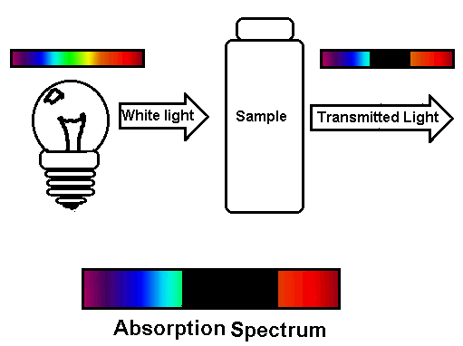

Missing

In the figure at right, a white light source is aimed at the sample. Although the white light is a mixture of all visible wavelengths, not all are able to pass through the sample. Consequently, those wavelengths (colors) that don’t pass through the sample we say are “absorbed.”

In the example at right, green and yellow light fail to pass through the sample. We say that the green and yellow light was absorbed.

Alternatively, light that does pass through the sample, like the red and blue light, is transmitted.

Using a spectroscope or prism, we can observe what parts of the spectrum have been removed or absorbed. The observed spectrum is called an absorption spectrum. Light that is transmitted appears in the spectrum while light that is absorbed is replaced by darkness.

Typically, molecular species will absorb large segments of the available light spectrum as seen above.

On the other hand, atomic species absorb thin slices or lines that correspond to identical positions in the emission spectrum. In the lithium emission spectrum below, six emission lines are observed. When white light is projected through a gaseous lithium sample, most colors are transmitted. However, segments of the continuous spectrum that coincide with the emission spectrum are absorbed. These appear as dark lines in the absorption spectrum.

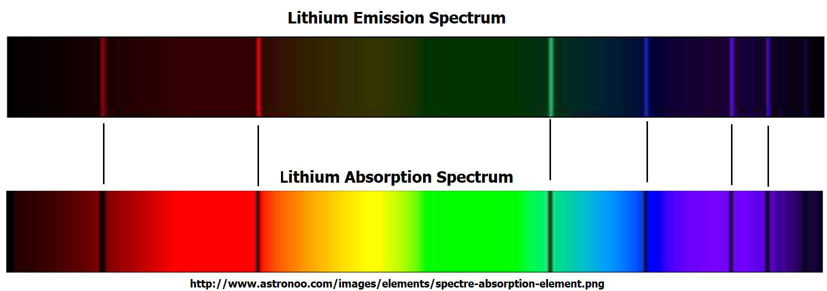

***Hazards Identification***

High voltage is present on the end-caps of the gas emission light sources. Do not touch these terminals while the light is in operation!

***Spectroscope Operation***

* Examine the spectroscope and locate the narrow slit.
* Aim the slit at the light source being studied.

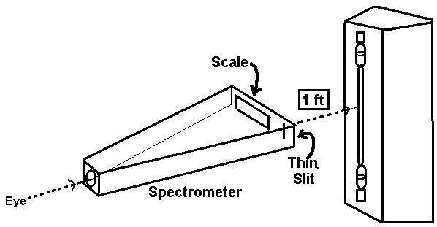

* Hold the spectroscope horizontally while moving it left and right until the brightest light is observed through the narrow slit.
* For best results, the spectroscope should be approximately 12 inches (30 cm) from the light source. A white light source is also used to illuminate the back of the spectroscope so that the scales can be seen.
* While keeping the location of the spectroscope locked in place, move your eye to the left to look at the spectrum.
* Using only the lower “Wavelength (nm)” scale, record the measurement of each line with 3 significant figures.



#### *Atomic Emission Spectra*

**High voltage discharge emission spectra:**

* Note: to extend the lifetime of the hydrogen lamp, it is connected to a timer and will cycle “on” and “off” automatically.
* Accurately sketch the spectrum of each element in your notebook.
  + hydrogen
  + helium
  + neon
* For hydrogen, also measure thewavelengths of the three hydrogen lines in a data table. If you see a fourth line around 400 nm, include it in your observations/measurements.

**Flame emission spectra:**

* This series of experiments must be performed in the hood, and you will work in pairs.
* Record the identity of your first salt solution
* Attach it to the nebulizer’s compressed air line and direct the mist into the air vents of the Bunsen burner (use the clamp supports instead of holding the container).
* Record the color of the flame.
* Observe the emitted light through your spectroscope and record the spectrum in your notebook. Detailed observations are important! *In some cases, instead of lines you will observe broader ranges of color. Do your best to shade in these areas paying close attention to where they begin and end. Record line positions as accurately as possible.*
* Disconnect the salt solution when finished.
* Repeat until all salt solutions have been observed.
  + NaCl
  + CaCl2
  + NiCl2
  + SrCl2
  + LiCl
  + CuCl2
* *Note: chloride ions to not produce light in the visible spectrum. Observed spectra are due solely to the metal ions.*
* Repeat for the unknown solution.

***Molecular absorption spectra***

* Position a white light source on one side of the sample. You and your spectroscope are positioned on the opposite side.

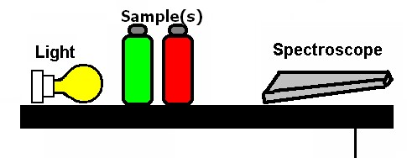

* Observe the transmission spectrum of each food dye or dye combination with your spectroscope. 
  + Red
  + Blue
  + Green
  + Yellow (can look orange)
  + Red/green
  + Blue/yellow
  + Red/blue
* Record which color(s) of the rainbow (ROY G BIV) that each dye or dye combination TRANSMITS.

