Solution Conductivities and Titrations
Minneapolis Community and Technical College
v.10.23

Objective: Introduce you to aqueous solutions, ion concentrations, conductivity measurements and acid-base titrations and techniques.

Prelab Questions: Read through this lab handout and answer the following questions before coming to lab.
There will be a quiz at the beginning of lab over this handout and its contents.
- List the ions formed when each of the following is dissolved in water: CuCl₂, Na₂SO₄, C₁₂H₂₂O₁₁, KBr, C₆H₆O₂,
- Consider a 2.30 Molar solution of FeCl₃. What is the concentration of each ion? What is the TIC for this solution?
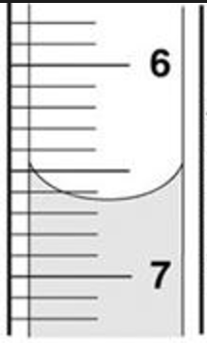
- A student measures a solution’s conductivity and observes the following fluctuating readings on the computer screen:
12345 S, 12490 S, 12302 S, 12289 S, 12388 S, 12201 S, 12475 S.
What should be reported as the solution’s conductivity?
- How is the solution stirred when performing the titration experiment?
- Which of the following solutions should have the greatest conductivity?
1.00 M KCl, 0.75 M Na₂SO₄ 0.80 M CaCl₂
- What is the correct reading for the burette measurement at right?
- Why does aqueous acetic acid conduct electricity better than pure acetic acid liquid?

Introduction:

Ionic solids (Salts … metal/non-metal) don’t conduct electricity until mixed with water to form an aqueous solution. Once dissolved, the ions are free to move and conduct electricity. If a molecular solid like sugar is dissolved in water, no additional ions are produced and the solution conducts electricity no better than the pure water did.

We use the following three terms to describe how well liquids and solutions conduct electricity:

- Strong electrolyte
  - Conducts electricity well
  - Solution contains a lot of cations and anions
  - Example: Table salt (NaCl) dissolved in water

- Weak electrolyte
  - Conducts electricity moderately
  - Solution contains a modest number of ions
  - Example: Acetic acid (CH₃COOH) dissolved in water

- Non-electrolyte
  - Conducts very little electricity
  - Solution contains few or no ions.
  - Example: Sucrose (C₁₂H₂₂O₁₁) dissolved in water

A solution conducts electricity in direct proportion to the number of ions present. For example, consider these two solutions: 1.5 M Ca(NO₃)₂ and 1.5 M NaCl. We will determine which of the two solutions contains more ions and is therefore the stronger electrolyte.

Being ionic substances (metal/non-metal combinations) each salt dissociates in water as follows. Note that NO₃⁻ is a polyatomic anion that doesn’t break apart.

NaCl_{(s)} ------> Na⁺_{(aq)} + Cl⁻_{(aq)}

Ca(NO₃)_{2(s)} ------> Ca²⁺_{(aq)} + 2 NO₃⁻_{(aq)}

Using the provided 1.5 M concentrations, we determine the concentrations of individual ions and the Total Ion Concentration (TIC). Consider the 1.5 M NaCl. Because 1 sodium ion is produced when the salt dissociates, we determine that the Na⁺ concentration is 1.5 M. The same reasoning applies to the chloride ion and its concentration is also 1.5 M.

However, the conductivity of the solution depends on the contributions of both the sodium and chloride ions combined. Therefore, we calculate the TIC by adding the individual ion concentrations together:

TIC_{NaCl} = Concentration _{Na+} + Concentration _{Cl-}
TIC_{NaCl} = 1.5M_{Na+} + 1.5M_{Cl-}
TIC_{NaCl} = 3.0 M

Having finished with NaCl, we now turn to the 1M Ca(NO₃)₂ solution. Like NaCl above, only one Ca²⁺ ion is produced when the solid salt dissociates. Therefore, the concentration of the Ca²⁺ ions is 1.5 M. However, two NO₃⁻ ions are produced making their concentration 2 X (1.5M) = 3.0 M. Calculating the total ion concentration we have:

TIC_{Ca(NO3)2} = Concentration _{Ca2+} + Concentration _{NO3-}
TIC_{Ca(NO3)2} = 1.5M_{Ca2+} + 2 X (1.5M)_{NO3-}
TIC_{Ca(NO3)2} = 4.5M

Because the Ca(NO₃)₂ solution has the larger TIC value, it contains more ions and will be more conductive. In fact, we can use TIC values to predict relative conductivities mathematically. Let’s say that the NaCl solution is measured and found to have conductivity of 15000 S (micro Seimans is a unit of conductivity). The Ca(NO₃)₂ conductivity can be predicted using ratios:
TIC_{Ca(NO3)2} Conductivity_{Ca(NO3)2}
---------------- = ---------------------
TIC_{NaCl} Conductivity_{NaCl}

Using the TIC values derived above for each solution we have:

4.5 M Conductivity_{Ca(NO3)2}
---------------- = ---------------------
3.0 M 15000 S

Solving for the Ca(NO₃)₂ conductivity we get 22,500 S. This is a 50% increase in conductivity in comparison to the 1.5 M NaCl solution even though both solutions were labeled as 1.5 M.

Molecular liquids, like glacial * acetic acid (CH₃COOH_{(l)}) don’t conduct electricity well and are considered non-electrolytes. This is because the covalent bonds that hold the molecules together are strong and resist breaking. Few, if any ions are produced and the liquid doesn’t conduct electricity.

* Glacial acetic acid is a pure substance and gets its name from the fact that when frozen, it forms long, beautiful crystals that resemble glacial ice.
However, when mixed with water, the acetic acid solution is more conductive than either the pure water or glacial acetic acid alone. This fact is due to water’s attraction to the acetic acid molecule via a force known as hydrogen bonding. Several water molecules, working together pull and break the bond connecting the hydrogen atom to the rest of the acetic acid molecule. This process is illustrated by the following chemical equation:

CH₃COOH_{(aq)} + H₂O_{(l)} ↔ H₃O⁺_{(aq)} + CH₃COO⁻_{(aq)}

Note that there are ionic products and these are responsible for the solution’s moderate conductivity.

We refer to the “left to right” conversion of reactants to products in a reaction like this as the “forward reaction.” However, once the forward reaction has created enough ions, it becomes likely that they will bump into one another and convert back into non-conducting reactants; something known as the “reverse reaction.”

Both the forward and reverse reactions are indicated in the chemical equation above by the double arrow.

At some point, the levels of non-conductive reactants and conductive products stabilize reaching a state known as dynamic equilibrium. Conductivity measurements reflect the equilibrium levels of product ions in the solution.

Experiment: Calibration of the Conductivity Probe

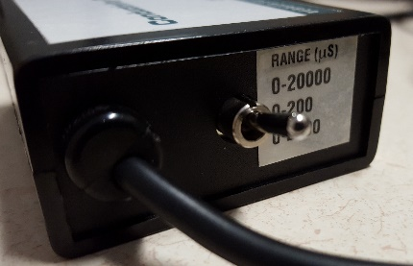

1. Assemble the computer, LabPro and conductivity probe (Channel 1).

2. Position the conductivity probe sensitivity switch on the 20,000 setting.
This setting will allow the greatest range of conductivity measurements.

3. Open the LoggerPro application:
The display gives solution conductivity in micro-Siemens (μS).

4. Calibrate your conductivity probe using two solutions of known
conductivity (see below):
Liquid 1: Distilled water (Conductivity = 0μS )
Liquid 2: NaCl_{(aq)} (Conductivity = 1000μS)

Calibration Procedure

The screen display is locked during the calibration process.

1. Click Experiment > Calibrate > Conductivity Probe
2. Click “Calibrate Now” in the sensor settings window
3. Immerse the conductivity probe in the distilled water sample
4. Stir using an up and down motion with the conductivity probe
5. Enter “0” in the text box
6. Click the “Keep” button when the VOLTAGE reading stabilizes
7. Rise off the probe with distilled water and blot dry with a tissue
8. Immerse the probe in the 1000 μS NaCl_{(aq)} calibration solution.
9. Type “1000” into the Reading 2 text box.
10. Stir with the conductivity probe using an up and down motion.
Keep the end of the conductivity probe immersed in liquid at
all times.
11. Click “Keep” when the voltage reading stabilizes
12. Click “Done”
13. Re-measure the conductivities of the two standard solutions to be
sure the conductivity probe reads correctly.

Conductivity Measurements

- Inspect the solutions on the tray provided.
You should have two water samples, three ionic solutions
and four molecular samples.
- Remove the cap from one vial and insert the conductivity
probe directly into the solution.
Be sure the conductivity probe’s lower electrode hole is totally
immersed at all times.
- Gently agitate the solution with an up/down motion of the
conductivity probe. Be careful not to splash liquids out of vials.

- Record the conductivity in your notebook while stirring.
Not all digits are significant and it is your responsibility
to determine what digits should be recorded.
Uncertain digits should be replaced with zeros used
as place-holders.

- After recording your measurement, remove the conductivity
probe and return the cap to the vial.
- Rinse the conductivity probe over the waste beaker
using a wash bottle and small amounts of distilled water.
One beaker is provided for the water/salt solution samples
and another beaker for the molecular samples.
- Gently shake excess water from the probe and dry it by gently
blotting the outside of the electrode assembly with a tissue.
It isn't necessary to dry the electrode’s interior hole.

- Use the above procedure to test all remaining solutions.
(Be sure to collect rinse solutions correctly)

Acid – Base titration

- Obtain a Ba(OH)₂ solution from the instructor and record
its number in your notebook.
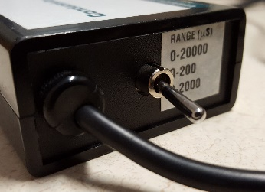
- On the conductivity control box, move the switch
to the 0-2000 μs position.
We will not be recalibrating the conductivity probe for this
experiment.
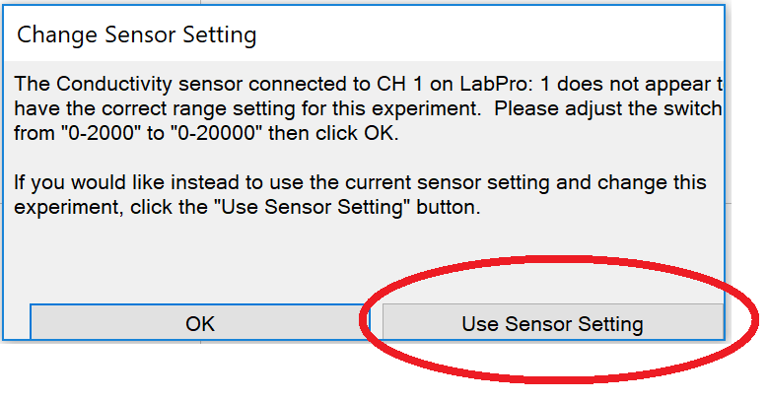
- When asked, click on the “Use Sensor Setting” button that
appears on screen
- Obtain approximately 35 mL of H₂SO₄ and write the
concentration of the acid in your notebook.

- Rinse the burette twice with 1-2 mL portions of the sulfuric acid.
Remove the funnel before starting your titration.
- Use the small funnel to fill the burette with H₂SO₄ and
eliminate any bubbles from the tip of the burette.
- Adjust the liquid level in the burette to read 0.00 mL.

- Use a graduated cylinder to measure out 20.00 mL of the Ba(OH)₂
solution and pour it into a clean 50 mL beaker.

- Place a small magnetic stirring rod in the beaker and position it
on the stir plate. (See picture next page.

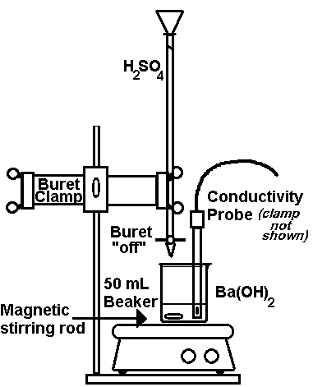
- Adjust the speed control on the stirrer to mix well but without
splashing.

- Use the articulated probe holder (not shown in figure) to support
the conductivity probe and position it in the 50 mL beaker.
Be sure the electrode hole at the bottom of the probe is completely
immersed in solution.

- Add 4 drops of thymol blue indicator to the beaker
- Position the burette containing the H₂SO₄ above the 50 mL beaker.

- Record the initial burette reading (0.00 mL) and conductivity in
your notebook.

- Add a small amount (~0.5 mL or less) of sulfuric acid to the beaker
and wait several seconds for the reading to stabilize.
Record the burette reading and solution’s conductivity.

- Continue adding small amounts of sulfuric acid.
With each addition, record the burette reading and conductivity.

- Use smaller increments (i.e. slow down) as you get closer to the
equivalence point.
- After reaching the equivalence, go beyond it in 1 mL increments
for a total of 4 mL.
- Dispose of your waste solutions in the appropriate waste container.

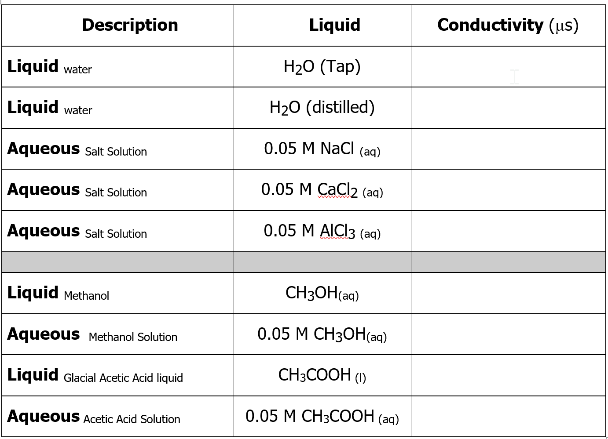

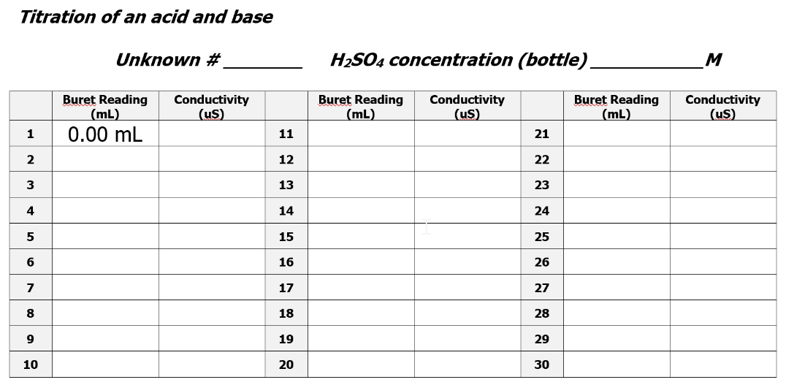
Answers to pre-lab questions:

- CuCl₂ : Cu²⁺ Cl⁻ Cl⁻ Na₂SO₄ : Na⁺ Na⁺ SO₄²⁻ C₁₂H₂₂O₁₁ : molecular … no ions
KBr : K⁺ Br⁻ C₆H₆O₂ : molecular … no ions
- Fe³⁺ concentration = 2.30 M Cl⁻ concentration = 6.90 M TIC = 9.20 M
- “1” and “2” don’t fluctuate and are “certain digits.” The third digit fluctuates but averages a “3”.
Reported value 12300S where zeros are used as placeholders and not significant.
Represents a range of values from 12200 … 12300 … 12400 S
- A small magnetic stir bar is placed in the 50 mL beaker. The hotplate/stir-plate spins the stir-bar and stirs the solution. The solution is stirred briskly.
- Which of the following solutions should have the greatest conductivity?
1.0 M KCl TIC = 2.00 M
0.75 M Na₂SO₄ TIC = 2.25 M
0.80 M CaCl₂ TIC = 2.40 M (Most concentrated, most conductive)
- 6.64 +/- 0.01 mL
- Water molecules interact with the acetic acid molecules pulling them apart to form ions.

