Determining the Empirical Formula of Zinc Iodide _{v.1.22}
MCTC Chemistry

Objective: To conduct a zinc/iodine reaction and use reactant mass measurements to determine an empirical formula for the product that is made.

Prelab Read through this lab handout and answer the following questions before coming to lab.
Questions: There will be a quiz at the beginning of lab over this handout and its contents.
1. What are several precautions you should take when using the analytical balance?
2. In today’s experiment, which of the two reactants (Zn or I₂) is left over when the reaction is finished?
3. Why is it necessary to dissolve the I₂ in methanol?
4. How do we prevent I₂ gas from leaving the 125 mL Erlenmeyer flask?
5. What do you do to keep the reaction mixture from boiling dry when heating?
6. What does it mean to “decant”?
7. In what container is the product located at the time it is weighed?
8. Look up the term “Hygroscopic” and know its meaning.
9. What chemical is used to wash the zinc once the reaction is finished?
10. What should you do if you spill a chemical?
11. How do we know when the Zn and I₂ reaction is complete?
12. Small amounts of sand and salt are placed in an empty 250 mL beaker. Given the following
mass measurements, determine the sand and salt masses.
m_{beaker} = 255.63 grams m_{beaker + salt} = 271.45 grams m_{beaker + salt + sand} = 283.07 grams

Chemistry Overview

In this experiment, you will react solid zinc with solid iodine (I₂) and then determine the empirical formula of the zinc iodide product that forms. However, simply placing Zn metal in contact with solid I₂, won’t produce a significant reaction since the materials are not in close enough contact with one another.

For this reason, we will be reacting Zn metal with I₂ that is dissolved in hot methanol. The dissolved I₂ molecules are now able to make much better contact with the Zn metal and the reaction proceeds much faster. Heating increases the energy and frequency of atomic collisions and this increases the speed of product formation.

Balances

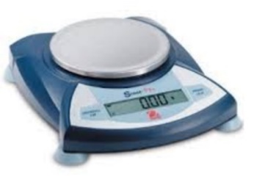
Top Loading Balance
The first and least expensive balance is the “Top Loading Balance.” It costs about $250, has a maximum capacity of 400 grams and has 2 decimal place accuracy.

When using a top loading balance, be sure to place a weighing paper on the balance pan. Then “Tare” or “Zero” the balance before making your measurement.

Always use the same balance for multiple mass measurements.
Report and clean up all spills. Your instructor will give you cleanup instructions.

Analytical Balance

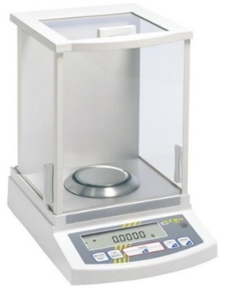
Analytical balances cost about $3500 and have 4 decimal place accuracy. The additional two decimal places (compared to a top loading balance) are what make the analytical balances so expensive. Generally, in science, more accurate measurements cost more.

Analytical balances have sliding doors to keep dust out and to keep air movement from affecting the measurement. Close the doors while making the measurement and close them when you finish to keep dust out.
When using an analytical balance, be sure to place a weighing paper on the balance pan.

Also, remember to “Tare” or “Zero” the balance before making your measurement.

Never move an analytical balance and don’t lean on the benchtop while making a measurement.

Weighing by Difference
When you need to know the mass of something like a small stone, you can place it directly on the balance pan.
However, when you need to know the mass of a solid powder or liquid, you’ll need to use a container; frequently a flask or beaker and there are two ways of doing this.
The first method is to place the empty container on the balance pan and then press the “TARE” or “ZERO” button. The balance display will now read 0.00 grams. Next, you remove the container from the balance, add the chemical to the container and return it to the balance. The balance now displays the chemical’s mass.
A second method is to weigh the empty container and record its mass. After adding the chemical, the container is returned to the balance and reweighed. The difference between these two measurements is the mass of the chemical.
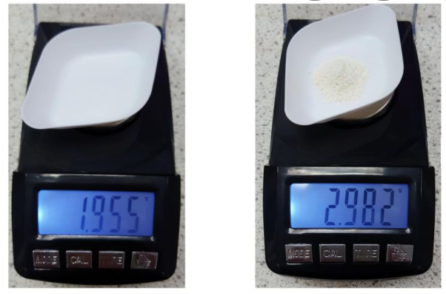
In the example below, the mass of a dry white powder is determined by difference measurements:
First, an EMPTY plastic weighing boat (figure at right) is weighed to determine its mass: 1.955 grams.
Next, the chemical is carefully scooped into the weighing boat which is then re-weighed: 2.982 grams
The mass of the chemical is determined to be
2.982 g – 1.955 grams = 1.030 grams

In the same way the masses of more than one chemical can be determined from multiple mass measurements. Consider the following:
m_{flask} = 91.44 grams m_{flask+H2O} = 154.82 grams m_{flask+ H2O+NaCl} = 167.99 grams
The mass of the water can be determined as follows:
154.82 grams – 91.44 grams = 63.38 grams_{H2O}
The mass of the NaCl can be determined as follows:
167.99 grams – 154.82 grams = 13.17 grams_{NaCl}
Cut out the following procedures
and glue into your lab notebook.

Experiment: Procedure
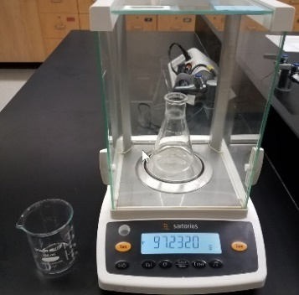
- Label and pre-weigh a clean/dry 125 mL Erlenmeyer flask
and a clean/dry 150 mL beaker on the analytical balance.
Record their respective masses in your data table.

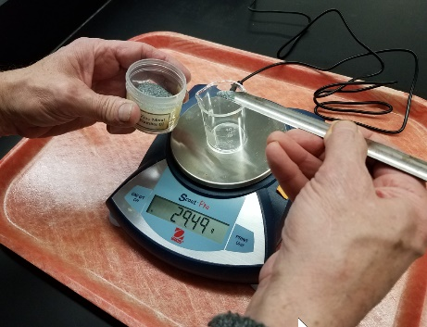
- Use a spatula and the top loading balance to weigh
out between 0.9 and 1 grams of metallic Zn granules
in a clean/dry 50 mL beaker.

- Transfer the zinc granules from the 50 mL beaker to
125 mL Erlenmeyer flask.
Reweigh the 125 mL Erlenmeyer flask and its contents on
the analytical balance and record the value in your data table.
Calculate the mass of the zinc in the flask and record
this value with 4 decimals in the data table.
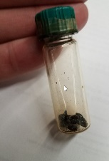
- Obtain I₂ from your instructor. Shake
the capped vial vigorously to loosen
the I₂ crystals.
- Transfer all the solid I₂ to the
125mL Erlenmeyer flask.
Reweigh the flask (analytical balance)
and record the mass in the data table.

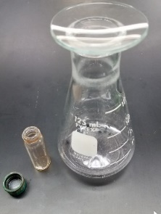
- Cover the 125 mL flask with a small watch glass to keep
gaseous I₂ from escaping into the atmosphere.
- Calculate the mass of the solid I₂ to 4 decimal
digits and record this value in your data table.
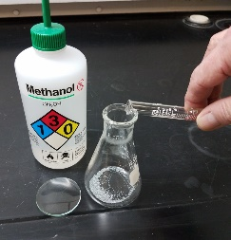
- While working in the fume hood, add approximately 15 mL
of methanol to the 125 mL flask using the graduated
cylinder.
Cover the flask with the watch glass.
Record the before and after colors in your lab notebook.
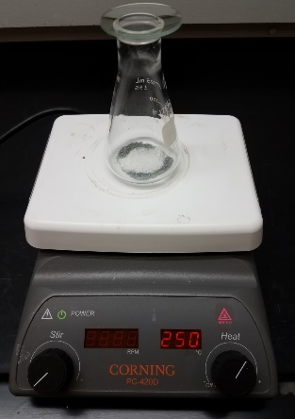
- Continue working in the fume hood and gently heat the
flask with the hotplate (250 ºC) until it gently boils.
Adjust the heat setting if necessary.
  - Don’t leave your experiment unattended!!!
If you must leave your station, have someone
else watch things until you return.
  - The watch glass will keep most of the methanol
from escaping. However, you may have to add
small amounts of methanol if you see
the level drop.
  - Don’t allow the solution to boil dry
- Continue heating until the solution until it is colorless.
- Once colorless, carefully remove the flask from the
hotplate and allow it to cool.
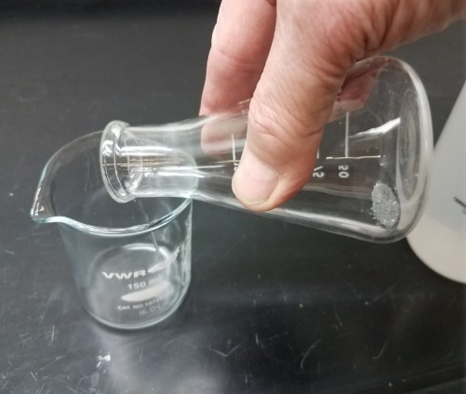
- Decant (pour off) the liquid in the flask into the
pre-weighed 150 mL beaker leaving the un-reacted
Zn in the flask.
- Rinse the zinc in the flask by adding approximately 5 mL
of methanol to the reaction flask and then gently re-heating
for 15 seconds.
  - Decant the methanol rinse solution into
into the 150 mL beaker.
  - Repeat this rinsing procedure two more times.
- Place the 125mL Erlenmeyer flask (containing the
un-reacted Zn) on the hot plate and allow
the Zn granules to thoroughly dry.
Gently shake the flask side to side to accelerate
the drying process.

- When the Zn in the reaction flask is dry, cover it with
the small watch glass and let it cool.
Remove the watch glass cover and re-weigh the
flask on the analytical balance and record your result.
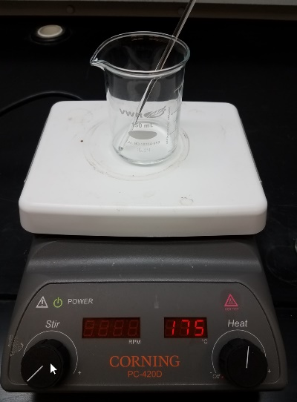
- Place the 150 mL beaker containing the methanol
solution on the hot plate and boil to dryness.
This MUST be done gradually at low heat (<200ºC)
and in the fume hood to protect us from methanol vapors.
A glass stirring rod should be left in the beaker as it will
improve the boiling behavior of the solution and reduce
bumping. Remove the glass stirring rod before the liquid
has completely been boiled off.
- Remove the beaker from the hotplate, cover it with a large
watch glass and let it cool.
- Re-weigh the beaker (no watch glass) on the analytical
balance and record this measurement in your data table
The dry, solid product that now coats the inside of the
150 mL beaker is hygroscopic.

- Use your measurements to determine the masses of zinc
and iodine that have actually reacted to form product.
Convert these mass quantities into moles and determine
the empirical formula of the product.

 | Balance # _________ | Mass (g)
Before Heating | 125 mL Flask
 | 150 mL Beaker
 | 125 mL Flask & Zn
 | 125 mL Flask & Zn & I₂
 | Initial Zn mass (Calculated)
 | Initial I₂ mass (Calculated)
After Heating | 125 mL Flask & Zn
 | 150 mL Beaker + product
 | Product mass
 | Excess Zn mass
 | Mass of I₂ Consumed
 | Mass of Zn Consumed

