Computer Survival Skills in C1151 Laboratory
MCTC Chemistry
v.1.5.2022

Objective: Introduce you to computerized data acquisition, data handling and display in the chemistry laboratory.

Prelab Questions: Read through this lab handout and answer the following questions before coming to lab.
There will be a quiz at the beginning of lab over this handout and its contents.
- What is the LabQuest mini device?
- If the LoggerPro “Collect” button isn’t green, what should you do?
- Approximately how long (in seconds) is an entire experimental trial?
- Why is it important for you to save your data before you leave lab at the end of the period?
- How do you identify a successful experimental trial in today’s experiment?
- What is the name of the computer application that we use to collect experimental data?
- Why is the “Heat” control of the hotplate turned off?
- What size beaker is used in this experiment?
- What stirs the water in today’s experiment?
- What is an articulated arm and what is it used for?
- What channel is used by the temperature probe?
- If the hot/stir plate doesn’t work, what should you do?
- When is the lab report for this experiment turned in?
- What is the last page of the lab report?
- Before coming to lab, what should you do?
- How should the temperature probe be positioned in the beaker of water?
- How much ice is used in today’s experiment?
- What features does a “professionally prepared graph” have?
- What is your lab section number?
- Where does the hot water come from in today’s experiment?

Before coming to lab:
Print and cut out the three procedures below and glue them in your lab notebook.
Record the experiment name and page number in the notebook’s table of contents.

Experimental Procedure Part 1
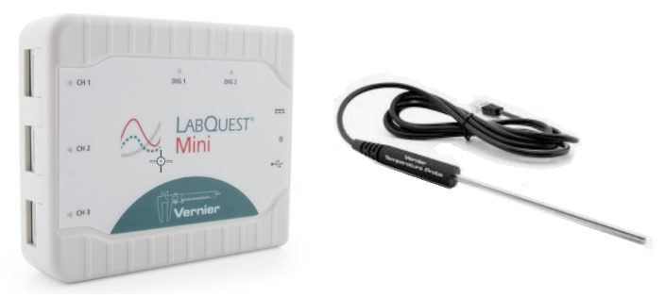

- Obtain a laptop computer and charger. Connect the charger to a wall outlet and the computer.
- Locate the LabQuest Mini (figure above) and plug its USB cable into the computer.
- Locate the stainless steel temperature probe and plug it into Channel 1 of the LabQuest Mini interface.
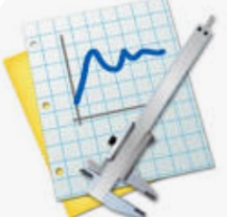
- Activate (double click) the LoggerPro software application found on the computer’s desktop.
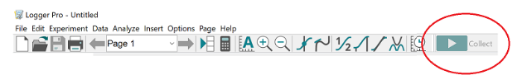
- Is the “Collect” button green? If it isn’t, check all connections (probe and USB).
- Configure data acquisition.
Click on the “Experiment” drop down menu and select “Data Collection.” Change the experiment length to 5 minutes (300 seconds).
- Click the DONE button. You are now ready to collect temperature data.

Experimental Procedure Part 2

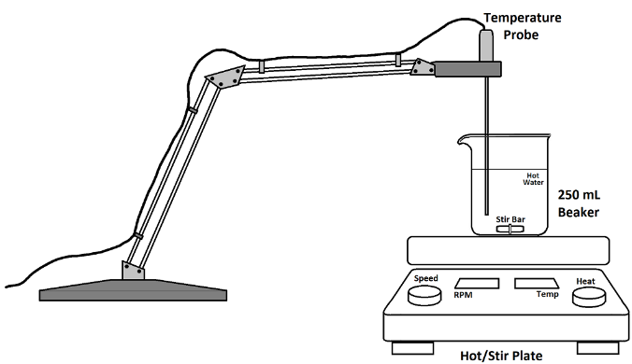

- Fill a 250 mL beaker ¾ full with hot tap water and place it on the center of the stir plate. (Picture above)
- Make sure the stir plate heat control is in the “OFF” position and plug in the stir plate.
- Place the magnetic stir bar in the beaker and set the stir speed for approximately 500 rpm. Stirring should be observed.
If the stir plate isn’t working, the power plug on the backside may have come loose. Push it into place.
- Use the articulated arm to position the temperature probe in the water.
The temperature probe should not touch the stir bar or the side of the beaker.
- Click the "Collect" button (Green button at the top right-hand corner) on the LoggerPro window to start data acquisition.
- After 2 minutes, add approximately 1/2 cup of ice to the hot water.
- Continue collecting data for 3 more minutes.
- Click the red "Stop" button. (Data collection should automatically stop after 5 minutes)

Is your experiment a success?

- Is your experiment a success?
  - If the lowest temperature reached is in
5ºC … 15ºC target temperature range,
you are done gathering data.
  - If the lowest temperature reached is NOT in 5ºC … 15ºC target range, you’ll need to repeat the above procedure using more or less ice as needed.
- Save your data:
  - Click in the LoggerPro data table.
  - Select all data (Ctrl a)
  - Copy data (Ctrl c)
  - Open Excel
  - Click on cell C3
  - Paste the data (Ctrl v)
  - Save the spreadsheet to the desktop using a the filename:
Introduction Your Name.xls
  - Open a browser and your email account
  - Compose a new email to yourself, attach the spreadsheet file and send.

- Your goal is to create a graph with the features demonstrated on the one below using YOUR data.

- Note that a professionally prepared graph has the following features:
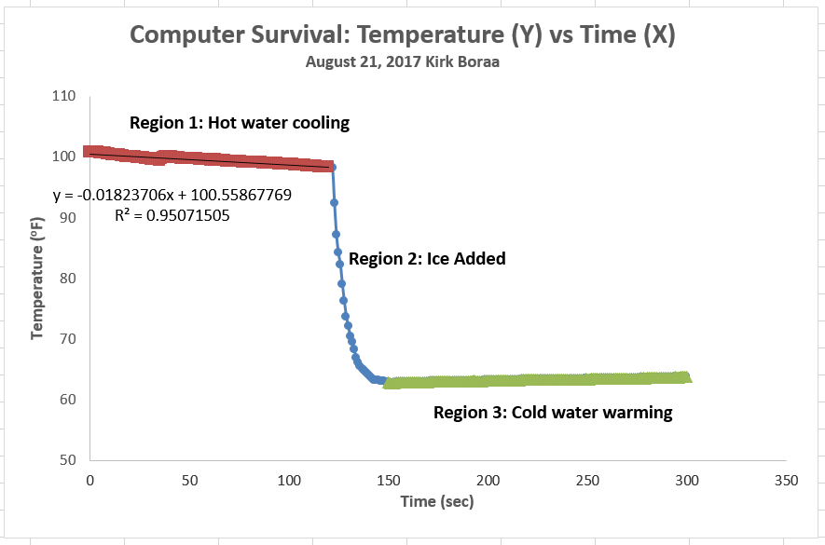

  - X and Y axis labels (with UNITS)
  - 2 line Title
  - Descriptive name (larger font)
  - Date and your name (smaller font)
  - Axis scale limits adjusted to display data fully with no large regions of empty space

