Beer's Law: Determination of an Unknown Solution's Concentration
Minneapolis Community and Technical College
v.3.22

Objective: To prepare a set of standard solutions for colorimetric analysis and use them to generate a calibration curve. The calibration curve will be used to determine the concentration of an unknown solution.

Prelab Questions: Read through this lab handout and answer the following questions before coming to lab.
There will be a quiz at the beginning of lab over this handout and its contents.

- Why not use green light to evaluate the green solutions used in today’s experiment?
- How many times is the colorimeter “calibrate” button pressed in today’s experiments?
- What precautions are taken when cleaning the cuvette?
- What is a Beer’s Law plot?
- How many standard data points should there be on your Beer’s Law plot?
- Use the dilution equation to determine the concentration of a solution created by mixing 3.0 mL of 0.25 M NaCl with 8.0 mL of distilled water. (Answer 0.069 M)
- Between colorimetry measurements, what precautions should be taken?
- How do we consistently position the cuvette in the colorimeter?
- What is a “Standard?”
- Using the Beer’s Law plot trendline on the next page, calculate the concentration of an unknown
whose %T = 51%

INTRODUCTION

Think back to the experiments with light absorption and food colorings. As you discovered, colored water solutions appear the way they do because of the light they transmit. For example, a blue solution transmits mostly blue light and that’s what we see or detect with our eyes.

In this week's experiment, we are going to utilize the absorption characteristics of a green, aqueous dye solution to determine its concentration. Because more concentrated solutions appear darker and dilute solutions appear lighter, you can use your eye to order or rank solutions of differing concentration if their differences are great enough. However, if the concentrations are similar, it can be difficult or impossible to compare them and see differences with the naked eye.

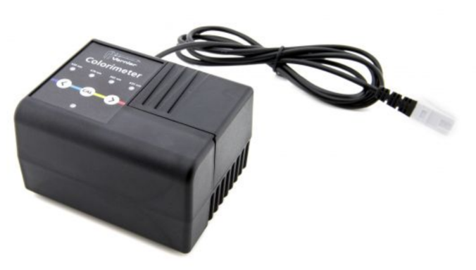
Instead of our eyes, we will be using an electronic device called a colorimeter (figure at right) to determine how light absorption is related sample concentration.

This device provides light at either 565 nm (Green), 635 nm (Red), 470 nm (Blue) or 430 nm (violet) wavelengths.

Light of the chosen wavelength passes through the sample and then strikes a detector which measures how much light gets through.

This information is sent to the computer where the Logger Pro data acquisition program determines the percent of the original incident light intensity that passed through the sample. This is known as percent transmission or simply %T.

In this experiment your will prepare and test six solutions known as “Standards.” Each standard has a different but known concentration of green dye ranging from 0.00 M to 0.400 M. The first solution contains only distilled water and is referred to as the "blank". It is used to determine the 100% transmittance point (all light is passed) since there is no dye present.

In subsequent trials, the concentration of the green dye is increased. Because these solutions absorb increasing amounts of light, less light reaches the light detector and a lower % transmittance is measured.

After preparing the six standards and gathering the % T data, you will convert %T into absorbance using the following equation:

Absorbance = - Log(%T/100)

While % transmittance is a number that tells us how much light gets through the sample, absorbance is a number that tells us how much light is blocked by the sample. In a way, %T and Absorbance are opposites of each other.

You’ll next create an Absorbance vs. Concentration graph; otherwise known as a Beer’s Law Plot. When graphed in this way, concentration and absorbance standard data points produce a nearly linear graph (below).
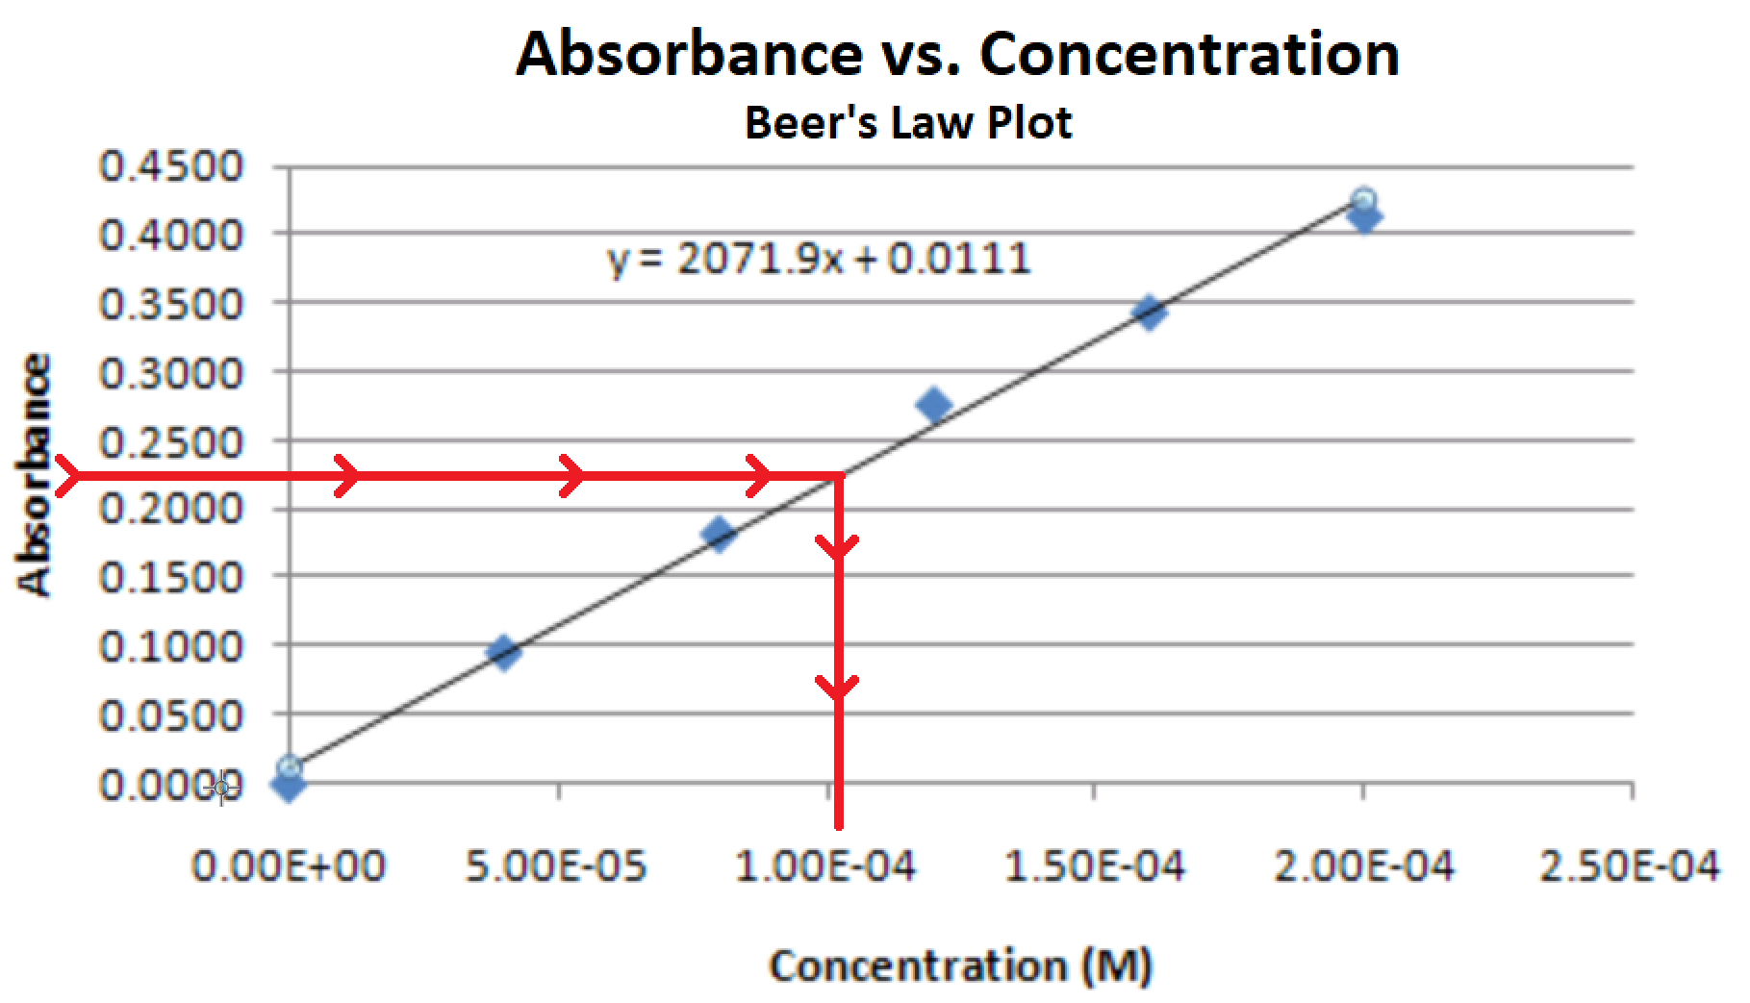

After graphing your six standard (Concentration, Absorbance) data points, you will use the trendline analysis equation to determine the concentration of an unknown solution from its measured %T and absorbance values mathematically. The red arrows above illustrate how you would determine the concentration graphically.

Part of your lab report grade will be determined by
how close your measured unknown concentration is to the known value.

Experiment: Burette Operation
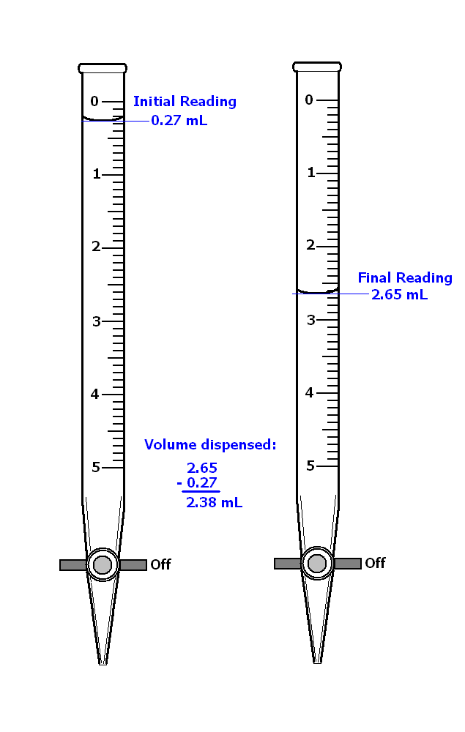
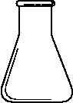
titer
titrant

The burette is a device that is used to dispense a liquid, the titrant, into a flask or beaker containing a different solution, the titer. Before use, the burette must be rinsed with the titrant solution to remove contamination that may be the result of prior use and/or dishwasher residue.

Note also the position of the burette’s valve handle. When perpendicular to the body of the burette, the valve is off. The burets in the figure at right are turned off.

Rinse the burette by first closing the valve and then adding approximately 2-4 mL of titrant solution (record the bottle number). Now tilt the burette (almost horizontal) and allow the titrant solution to run in the direction of the open end. Just as the solution approaches the open end, spin the burette between your fingers but don’t let the solution run out of the burette’s open end onto your fingers!! Discard the rinse solution as instructed. Now rinse the burette a second time.

Fill the burette using a small plastic funnel (valve off). Run out enough liquid to remove any bubbles that may be trapped in the tip. Record the initial reading to 2 decimal digits (see figure at right).

Note that burets are read from the top down UNLIKE graduated cylinders that read from the bottom up. Don’t make the mistake of reading the first buret (figure at above) as 1.73 mL. The correct reading should be 0.27 +/- 0.01 mL.
Slowly add titrant solution until you near the endpoint, signaled by a faint color change (pink for phenolphthalein) that lasts for progressively longer times.

Watch for bubbles that may be hiding in the valve assembly. If you see one, it must NOT be allowed to flow out the burette’s tip. If the bubble comes out, the titration will be in error and must be performed again. You may be able to continue by slowing down the titration.

Look for a color change early on as the titrant solution first encounters the solution in the beaker or flask below. Failure to see a color change means you forgot to add the indicator!

Note: During a titration, the meniscus must always fall on the burette’s graduated scale! Don’t let the meniscus drop below the lowest mark or you will have to repeat the trial!

Two methods may be used to add the last, small amounts of titrant near the endpoint.

- Quickly turn the valve 180 degrees from one off position to the next. When performed quickly enough only a small amount will be added to the beaker. PRACTICE THIS TECHNIQUE PRIOR TO DETERMINING YOUR ENDOINT.
- Slowly open the valve and allow a small partial droplet to form at the end of the burette. Rinse this droplet from the tip of the burette using a small amount of water into the beaker below. The small amount of water should have no effect on your result.
Cuvette handling and sample volumes

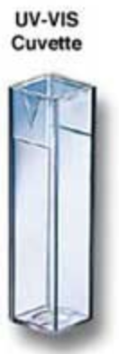
Samples are transferred to a cuvette which is then placed in the colorimeter for measurement. The cuvette has ribbed sides and clear windows as in the figure at right.

Cuvette Tips:

- Keep cuvette’s clear windows clean and free from fingerprints.
- Handle the cuvette by its ribbed surfaces only. Don’t touch the clear windows.
- Clean the windows as needed with a damp tissue.
- Always rinse the cuvette with a small amount of the liquid to be measured. Discard the rinse solution.
- When working with multiple samples, start with the most dilute. That way, any dilute residue will not significantly affect the concentration of the next more concentrated sample.
- Use the same cuvette for all measurements.
- Fill the cuvettes with your samples 3/4 full.
- Tap the cuvette gently on the benchtop to eliminate bubbles that may be sticking to the inside surface of the clear windows.
- Use a lid on the cuvette to keep its contents from spilling.
- Always put the cuvette in the colorimeter the same way. This makes for more consistent measurements. Use the notch in the cuvette to reproducibly insert it in the colorimeter.
- When finished, rinse the cuvette with distilled water and leave it upside down on a paper towel to dry.

Experimental: Standard Preparation
- Dispense approximately 30 mL of 0.400 M green dye stock solution in a clean/dry 100-mL beaker.

- Dispense approximately 30 mL of distilled water in a clean/dry 100-mL beaker.

- Rinse and fill two burettes: one for water and the other for aqueous green dye solution.
- Obtain and label four clean, dry, screw top vials 2, 3, 4 & 5. Write the vial number on the lid of each vial.

- Accurately dispense 2, 4, 6, and 8 mL of 0.40 M green dye solution into Vials 2 - 5.
Record the actual volumes dispensed in the data table.
- Accurately dispense 8, 6, 4, and 2 mL of distilled water into vials 2 - 5.
Record the actual volumes dispensed in the data table.
- Cover securely and shake each vial to mix the contents.

- Keep the remaining 0.400 M stock dye in the 100-mL beaker to use as the sixth solution.
- Calculate the concentrations of solutions 2 – 5 and record these values in the data table.
- Obtain an unknown from your instructor and position it where it belongs in the series of standard solutions.
Draw and label the seven vials (with labels) in your lab notebook. Shade/color them appropriately to indicate why the unknown is where it is.
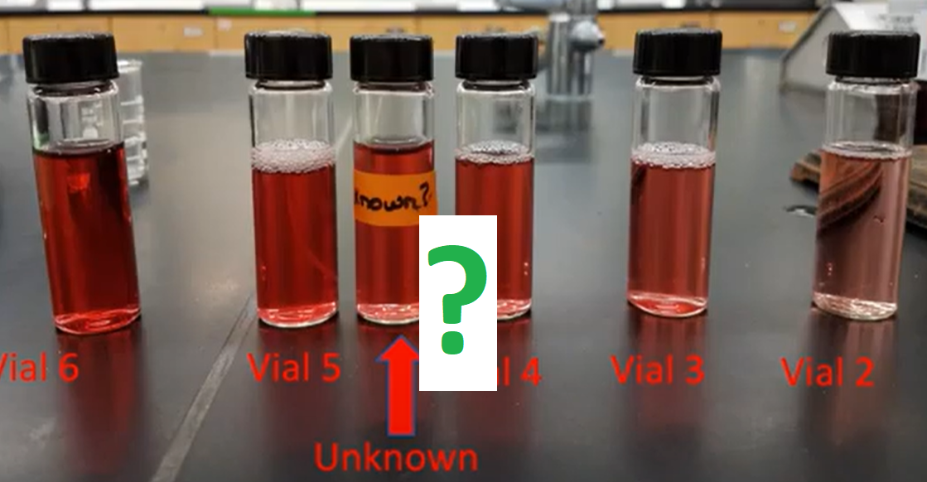

Experimental: Colorimeter Calibration:

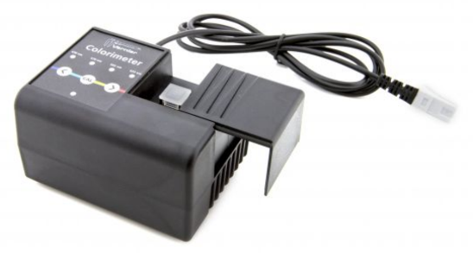

- Prepare a "blank" by filling a clean cuvette 3/4 full with distilled water.
- Open the colorimeter door and place the water filled blank cuvette inside. Make sure the cuvette’s smooth, transparent windows are facing right/left in the colorimeter.
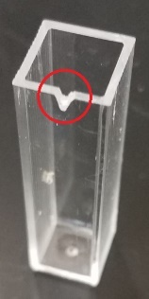
- Note the position of the notch on the cuvette (circled at right). Use the notch position to place the cuvette in the colorimeter the same way for all future measurements.
- Close the colorimeter door.

- Use the colorimeter’s arrow keys to select the 635 nm (red) light source.

- Press the “CAL” button. When the red light on the colorimeter stops flashing, it is ready for use and the computer display should read close to 100% T.

- If after calibration Logger Pro indicates something other than 100% (+/- 0.5%), alert the instructor who will then supply you with a new cuvette. Repeat the calibration procedure with the new cuvette.
- Record the %T for the blank in your data table.

- Use the same cuvette for all subsequent measurements.
- Do not press calibrate again.

Experimental: Standard Solution Analysis

- When testing a series of solutions, always work from low to high concentration. This is because concentrated solutions leave residue that can significantly change the concentration of a more dilute samples.

- Empty the water from the cuvette and rinse it twice with ~1mL amounts of the solution in vial #2 (the most dilute solution). Now fill the cuvette 3/4 full with the solution from vial #2.

- Use the notch to consistently orient the cuvette in the colorimeter.

- Close the colorimeter door and wait for the %T value displayed on the monitor to stabilize. Record the %T value for vial #2 in your lab notebook.

- Discard the contents of the cuvette in your waste beaker. Your waste beaker will be emptied into the sink at the end of the lab period.

- Repeat the above procedure (Rinse…rinse… measure) for the remaining three vials and for the 0.400 M stock dye solution. The best results will be obtained if each measurement is performed consistently the same way.

Experimental: Unknown Analysis

- Obtain an "Unknown" green dye solution from the lab instructor.
- Record its number on your data sheet
- Rinse the cuvette twice with the unknown solution and measure its %T as described above.

Experimental: Cleanup:

- Pour all used or leftover green dye solutions down the drain.

- Rinse your cuvette in distilled water and return it to your lab station. Position it upside down on a paper towel to dry.
DO NOT LEAVE CUVETTES IN COLORIMETERS

- Rinse the burets with distilled water and return them to your bench top. Position them upside down in the burette clamps for the next group of students to use.

- Rinse all sample vials with distilled water and return them to the benchtop to dry. Leave upside down on a paper towel.

- Examine the interior of the colorimeter for moisture. If it appears damp, alert the instructor.
- Double check that you haven’t left the cuvette in the colorimeter.

Trial # | 0.400 M GREEN |  | Water
 | Initial Burette | Final  Burette | Initial  Burette | Final  Burette | % Transmission
 | (mL) | (mL) | (mL) | (mL)
1 | ~ | ~ | ~ | ~
2
3
4
5
6 | ~ | ~ | ~ | ~
Unknown | ~ | ~ | ~ | ~

